**g**

# About the controller

Step2Mach is ethernet controller for Mach3 software.

It will use ST eval board –NUCLEO-F429ZI

https://www.st.com/en/evaluation-tools/nucleo-f429zi.html

# Plugin configuration

Copy Step2Mach.dll to Mach plugin directory (C:\Mach3\PlugIns\)

Run Mach3

Activate the plugin – choose OK

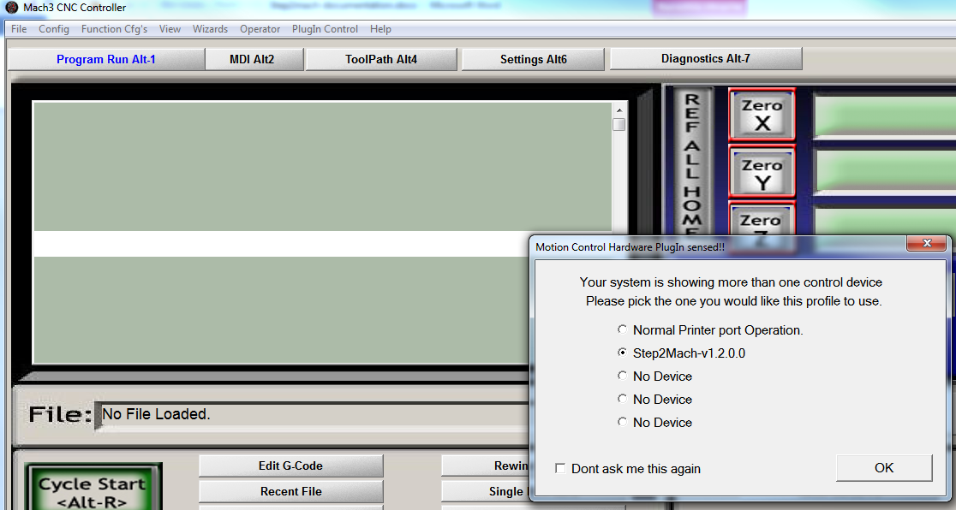

Configure plugin

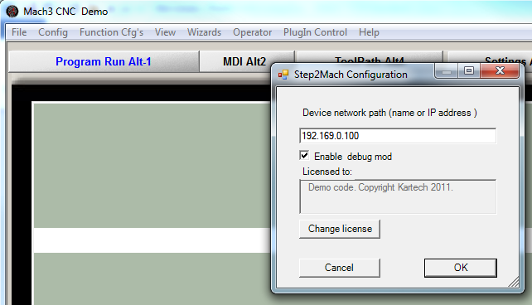

Note:

* Use IP address, not NetBIOS name
* Debug mode enables additional console window with dump of internal Mach variables. You may have to resize the window to be shown correctly as default 80x25 characters is not big enough
* The licensing system was disabled in the code.

# Firmware upgrade

Each time plugin connects to the device it checks for firmware version. In case of mismatch ( or missing firmware) it will upgrade it. The firmware is embedded ( compiled into) the plugin code.

# Todo list / known limitations

* Upgrade process needs improving – right now after successful upgrade user needs to press ESTOP again ( to force reconnection)
* Better visualization of connection/upgrade process
* Implement slaving support
* Implement threading support for lathes
* Implement spindle support

# Source code organisation

# Mach_common

Header files reusable between PC plugin and controller firmware.

## Mach_firmware

Firmware for motion controller. Debug version to be used without bootloader (directly), release to be embedded into PC plugin ( you need to copy it to mach_plugin\bootloader\fw\ and execute convert.bat to get fw.cpp file with encoded firmare. Change firmware version in convert.bat file if needed).

# Mach_plugin

PC plugin code.

# MachIncludes

Include files from Joshua Mach3 SDK (*Edward D. Bryson, Joshua 1 Systems Inc.)*

His webpage is here <http://www.j1sys.com/> , but the SDK is no longer seen there.

# Tools needed for the project

* Visual Studio Express 2010

<http://www.microsoft.com/visualstudio/en-us/products/2010-editions/visual-cpp-express>

* Microsoft DDK ( for ATL support)

<http://www.microsoft.com/download/en/details.aspx?displaylang=en&id=11800>

Note: You need to add DDK paths for include files and libraries to be able to use ATL

* Mach plugin wizard ( unknown location these days)

Note: The plugin was originally generated in the wizard. It references some of its header files which describe Mach interface